*You are government officials of a developing country. You came from a poor farming village and all of your family members are still back in the village farming. Your jobs in the government are focused around building up your nation’s economy so that poverty and food insecurity are greatly reduced. You are sent to a Global Summit as a representative of your nation to try and improve your nation’s economy.*

**Background Information:**

* The G8 country alliance (see below) are offering a “deal” called the New Alliance for Food Security and Nutrition, which will allow larger agribusinesses to invest large amounts of money into your country.
* This new deal requires dozens of laws to be changed or written. New policies and regulations need to be put in place to make your country more attractive to investors.
* Some of these policies will dictate which imported seeds farms may use, who they can buy them from, which crops can be grown for export, which company’s fertilizers can be purchased, etc.
* These new policies may require ring fencing huge amounts of land, displacing smaller farmers, but the thinking is that the small farmers will benefit from the new roads, power, wells, etc. that the giant agribusinesses promise to build.
* Having so many large foreign investors promises a lot more money flowing into your nation’s economy. Hopefully, this will lead to poverty reduction and improved food security and nutrition.
* You are concerned, however, that these changes are coming too fast. There are a lot of assumptions being made about what is going to be considered as improvements, and you know that the people of your village know nothing of these planned changes.

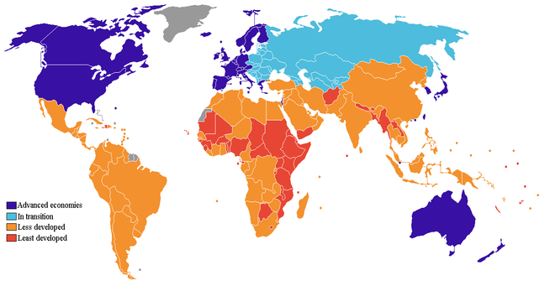

<http://worldissues2011.wikispaces.com/file/view/developed_and_developing_countries.png/223655478/648x341/developed_and_developing_countries.png>

G8 or Group of 8 Nations: The 8 most highly developed

nations on the planet that make up more than 50%

of all of the gross planetary income. Canada, France,

Germany, Italy, Japan, United Kingdom, United States

and the European Union. Russia was originally a

member but was suspended.